Beyond X Website -

Accord to PDF shared by Aghilan



Logo change orange color is fine need to add new color to previous X



Header section - Need to change

1. About X is home page
2. We offer
3. Change our clients to Works
4. Change contact us to connect
5. Careers
6. Insights ( blogs)

**1.Landing page - (About X)**

Landing Hero Section - Need to Add Illustration

* Welcome to BEYONDX technology Vision lab
* Add illustrations
* When you want something all the universe conspires in helping you to achieve it

-paulo coelho

Add this quote in landing page and a illustration like universe or globe with particle js

* Stand out among your competitors
* Add illustration and connect page link (button)



**2.We Offers**

We offer section -> Name change required **<Lokesh Add feedback>**

Change in content

Trust is the single most important concept in the world of digitalization

* Add quote and illustration
* Add 5 services with logo and sub services with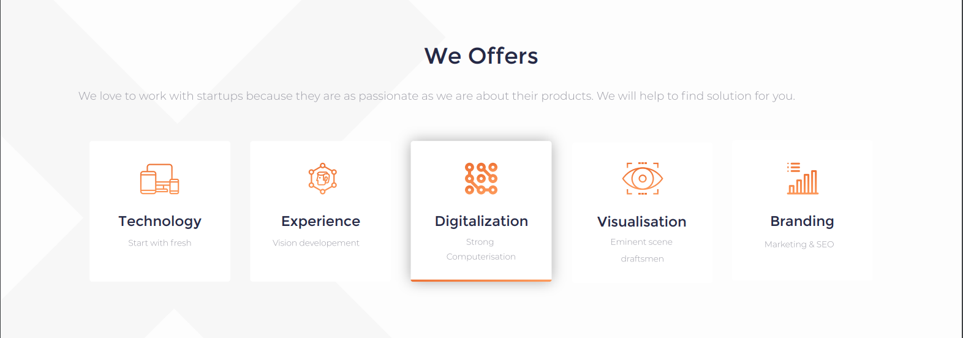
* Add sub services smtg like the below image as with favicons 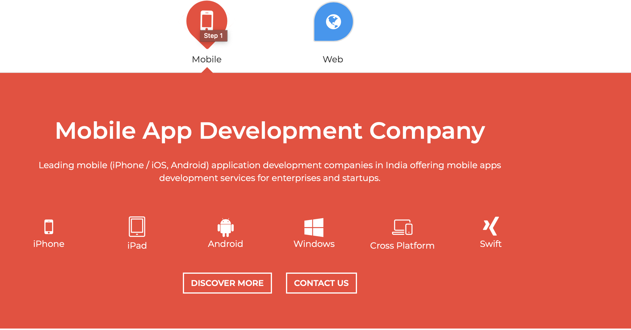
* 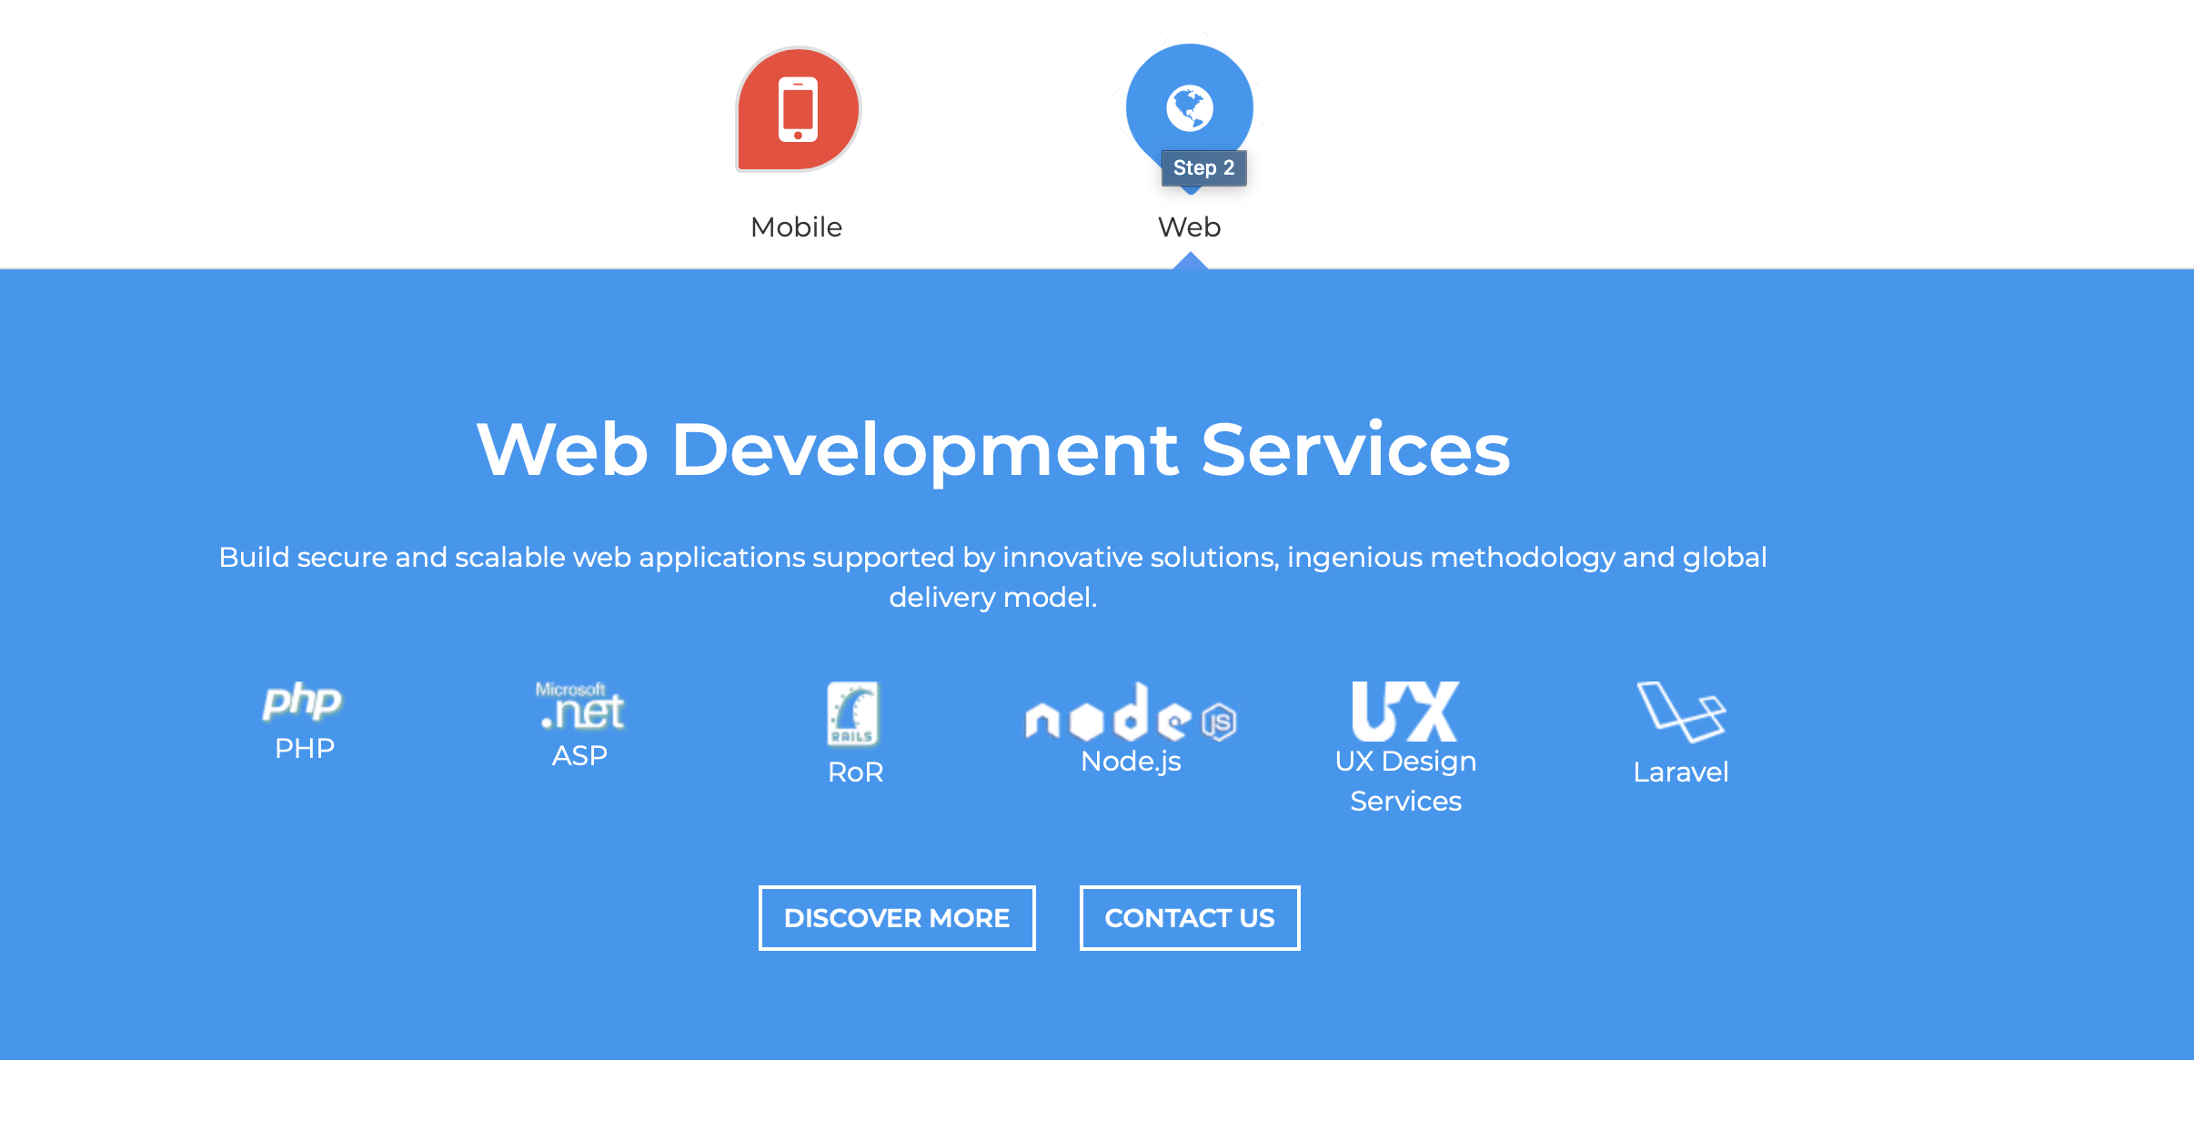
* Each sub service has 6
  + - Blending creativity & Technology creates a digital experience for industries
* Technology
  + API design & Development
  + AI
  + Cloud solutions GAA ( gcp, aws, azure)
  + IoT
  + BlockChain
  + DataScience
* Digitalization
  + Web optimization analysis
  + Devops
  + ERP end to end
  + CMS
  + SAP / Sales force
  + Chatbots
* Visualization
  + Virtual Reality
  + Mixed Reality
  + Augmented Reality
  + 3D design & Development
  + E- learning Content
  + Animation / Rendering
* Experience
  + Test Automation
  + Project Mapping
  + Motion / Gesture control
  + Multitouch Surface
  + 360 Video
  + ERD design Architecture
* Branding
  + Strategy & consulting
  + Data Analytics
  + Creative concepting (ui/ux)
  + Digital marketing
  + Seo/Smo
  + Integration
    - * We help to find solutions for your problems <add button to connect page>

**3.Works**

* + World economic forum forecast the digital economy to be 1.5 trillion

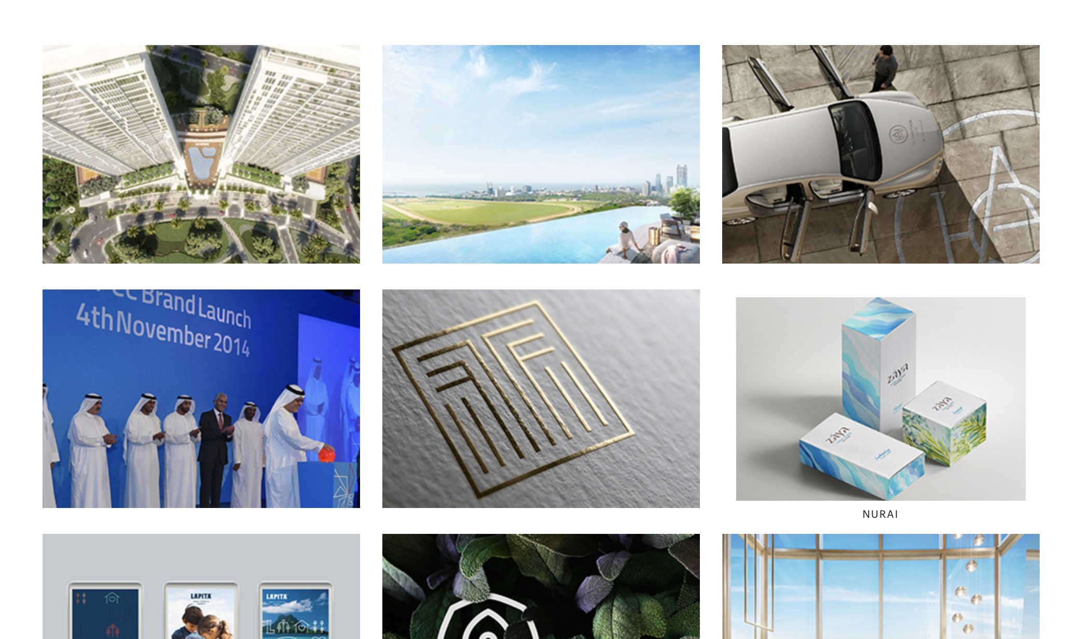

<:Put works like this >

What they say <testimonials>

Put logos in coursel and testimonials

**4. Connect**

Get a quote,-- Start your project,

* Add 6 d’s image with good illustrations
  + - Define
    - Design
    - Develop
    - Deliver
    - Deploy
    - Document

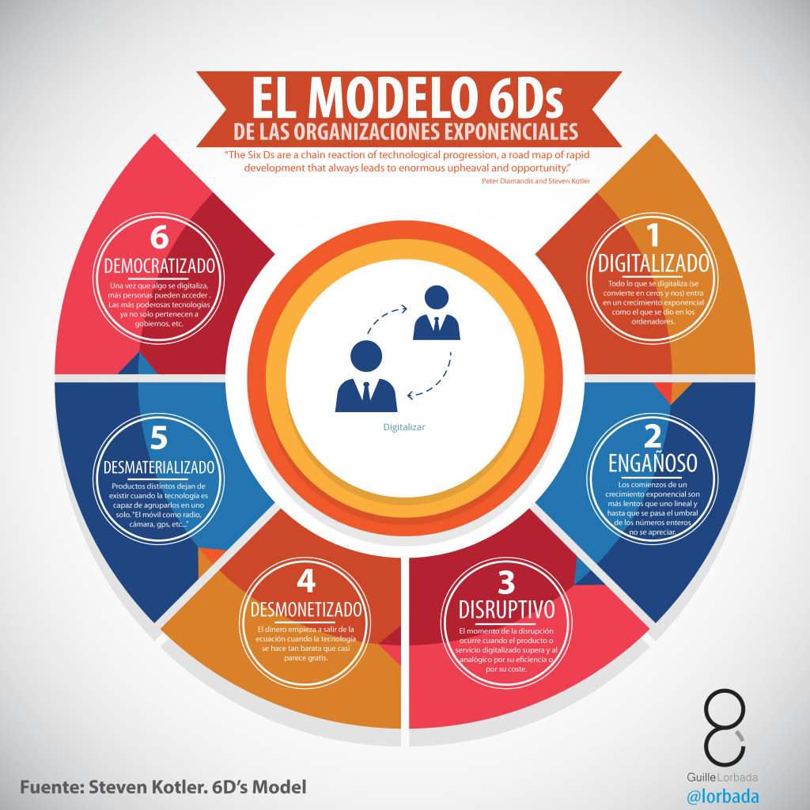<a illustration smtg like this>

* + World economic forum forecast the digital economy to be 1.5 trillion

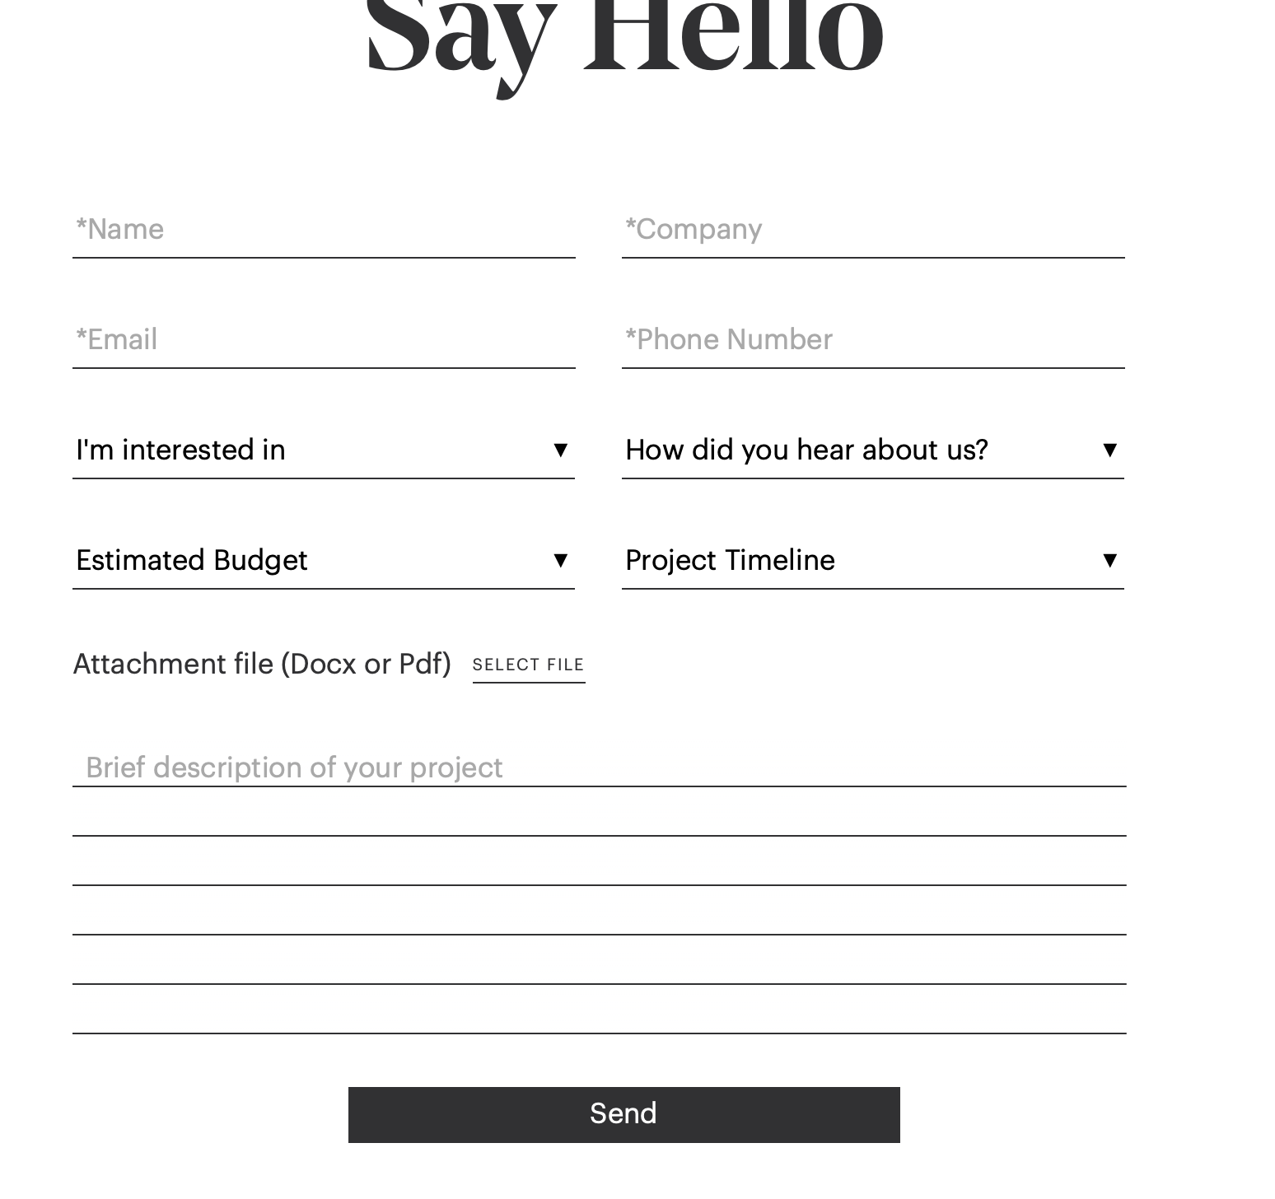

<need Form Here>

Form has to

* Name
* Email id
* Mobile no
* Company/Organisation- type / Name
  + Startup
  + Industry
* Intersted in
* How do you hear about us
* Timeline
* budget
* Upload document
  + - Word,pdf,excel,urls
* Description

Schedule a meeting -- Make your dream happen

<Mail id button > reach@beyondx.in

Add all social media like this



**5.Carrers**

Blending creativity & Technology creates a digital experience for industries

<add illustartions>

Job cards <need opening job cards> Always post developers, Strategist, Sales lead

<Redirct the form to [reach@beyondx.in](mailto:reach@beyondx.in)>

3 icons and a button redircts to form

Students internship / Program <iconns with button >

- Talented People / Graduates <icons with buttons>

- Partnership / investor <icons with button>

<button redirect to form>

* Need form here
  + Name
  + Email
  + Mobile no
  + Expertise in-
  + Year of Experince
  + Uplaod resume
* For Partnership/investors -form should contain
  + Name
  + Email
  + Number
  + Organisation (optionla)
  + Send
    - Give our no also in the form

**6.insights**

Industry needs and Leads

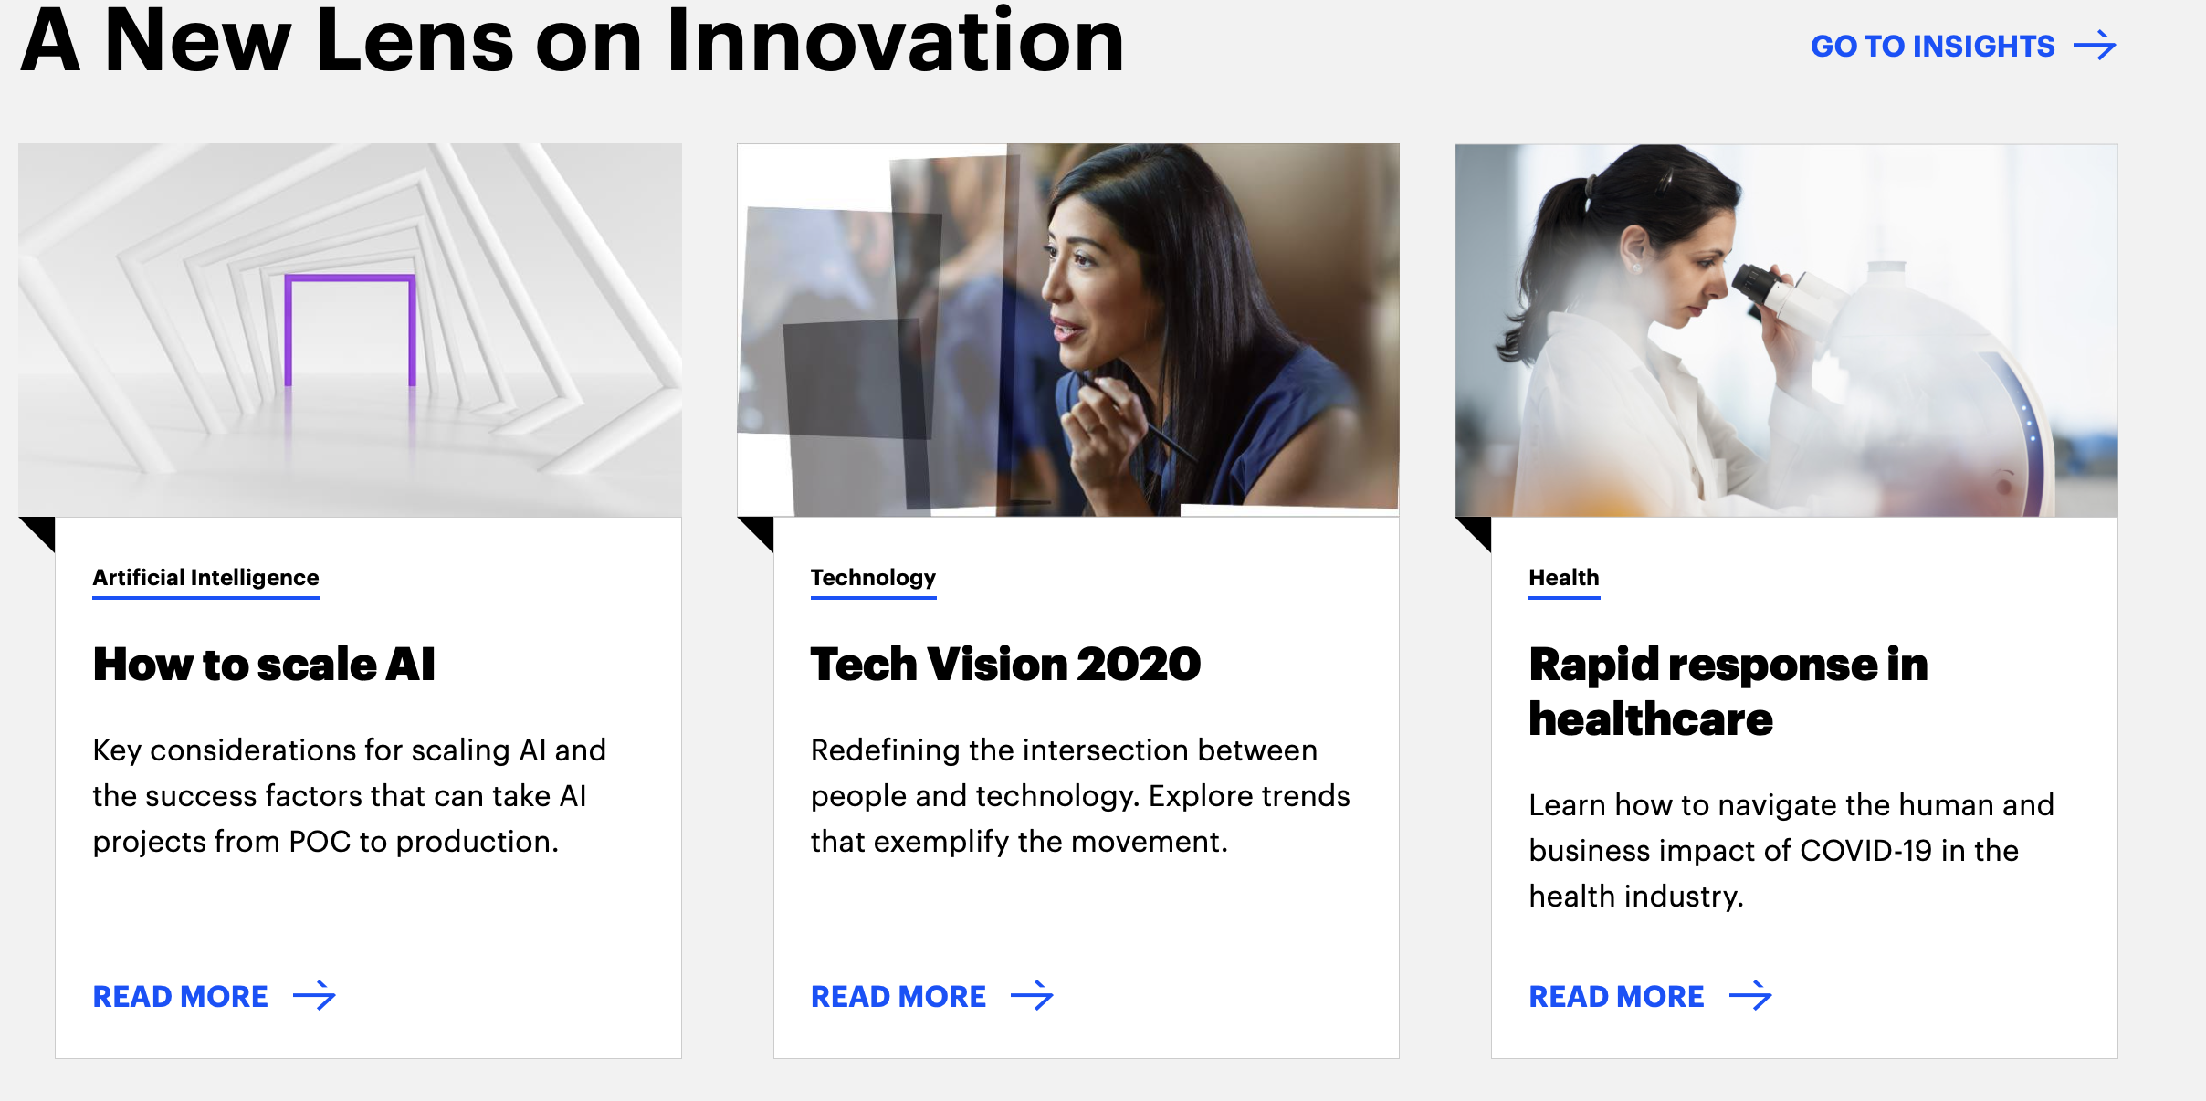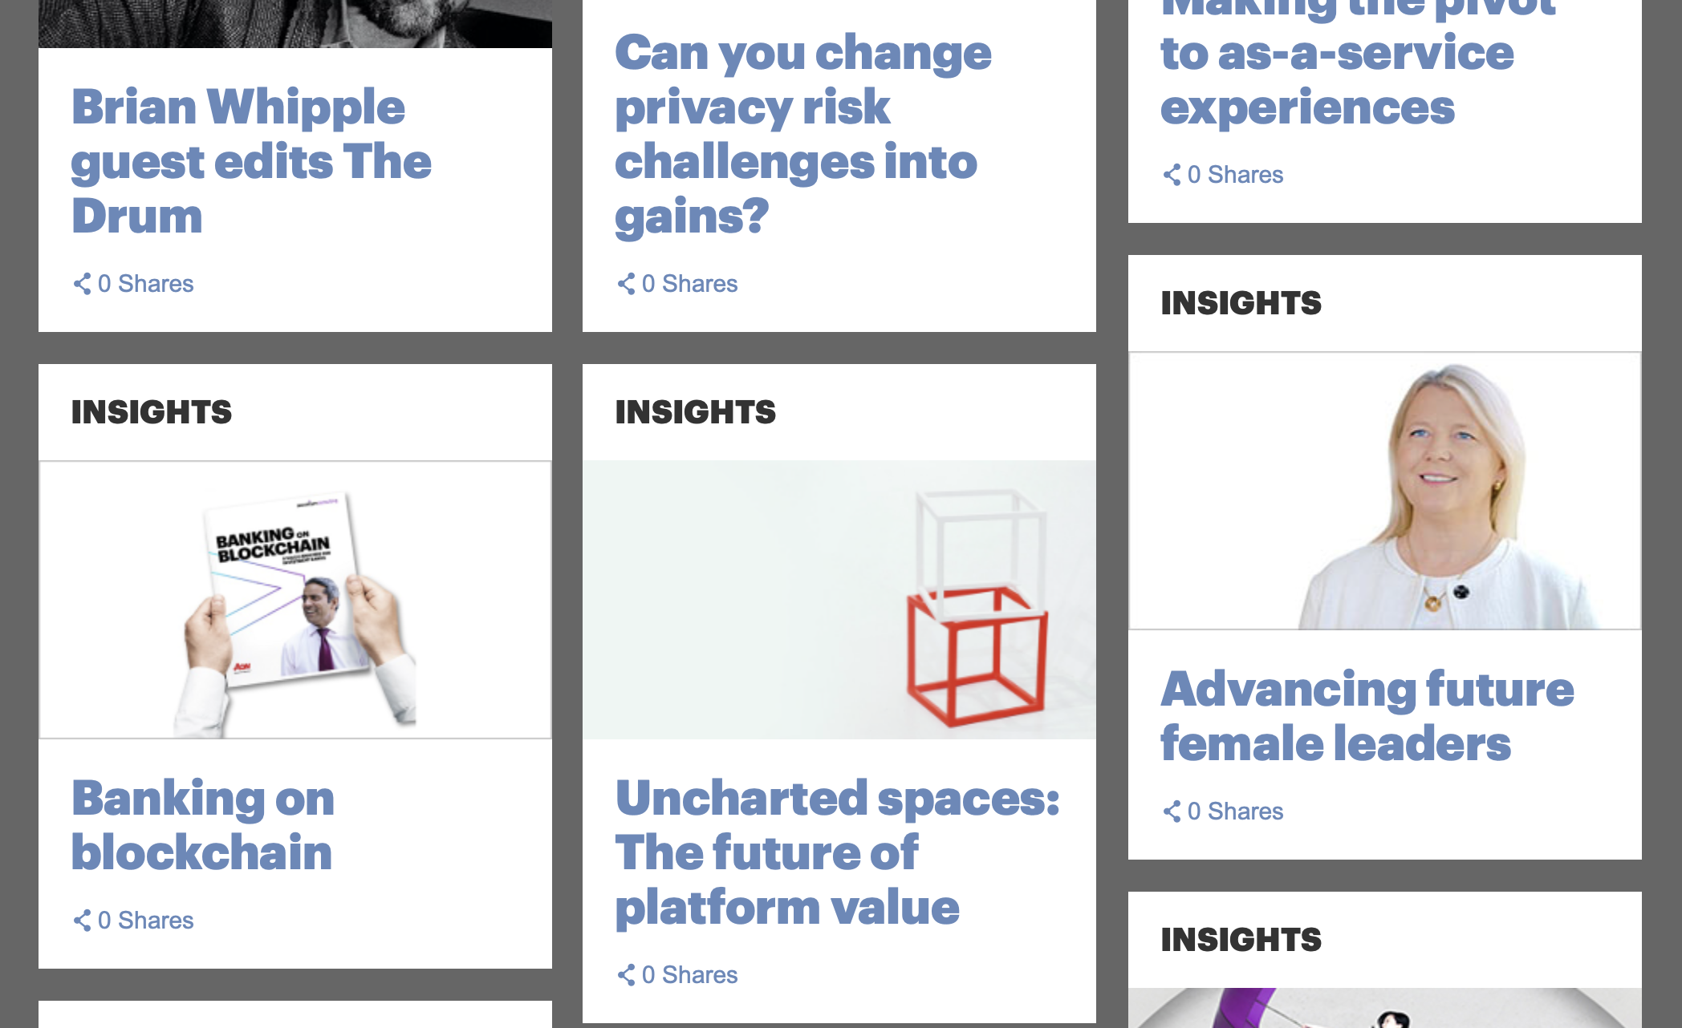

**7.Footer**

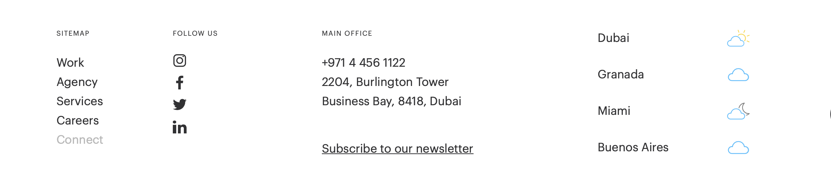

<put office in chennai, Banglore, Tirupathi>

Below this backlinks